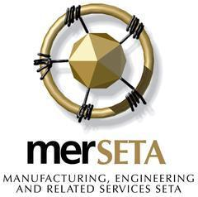
The WC Annual General Meeting (AGM) of the Manufacturing, Engineering and Related Services SETA (merSETA) to be held at the Southern Sun Cape Sun, 23 Strand Street, Cape Town on Friday 18 November 2022, at 09h00.

Response Form
Kindly complete information below and return as directed:
Name and Surname
Company Name
Designation
Mobile Number
Email Address
Dietary Requirements | Halaal |  | Kosher |  | Vegetarian
Other Requirements:

Kindly e-mail the response form back to:
- westerncape@merseta.org.za for the attention of KZN team

Please note that access to the agm is limited and will be allocated on a first-come first-served basis.

