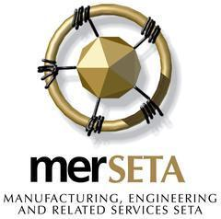
The KZN Annual General Meeting (AGM) of the Manufacturing, Engineering and Related Services SETA (merSETA) to be held at the Premier Hotel Umhlanga, 3-7 Umhlanga Ridge Blvd, Durban, 4319 on Friday 04 November 2022, at 09h00.

Response Form
Kindly complete information below and return as directed:
Name and Surname
Company Name
Designation
Mobile Number
Email Address
Dietary Requirements | Halaal |  | Kosher |  | Vegetarian
Other Requirements:

Kindly e-mail the response form back to:
- kznadmin@merseta.org.za for the attention of KZN team

Please note that access to the agm is limited and will be allocated on a first-come first-served basis.

